- The Bank of England's Monetary Policy Committee has stressed that it will take a cautious approach to loosening policy. Though this week's data on pay growth and inflation showed some signs of progress, the releases failed to deliver the large downside surprises needed for the MPC to cut rates more aggressively. So we still think sequential rate cuts are unlikely.
- GDP was flat in June, leaving output up 0.6% q/q in Q2. We think the economy will struggle to sustain the above-trend growth rates seen in H1 2024. But further real wage increases and rising consumer sentiment mean we still expect GDP to grow at a decent pace in the coming quarters.
In its August meeting minutes and press conference, the Bank of England's Monetary Policy Committee signalled that it would take a gradual approach to lowering Bank Rate. We interpreted this as meaning that sequential rate cuts are unlikely unless there's a sustained run of downside surprises for pay and inflation data. There was little in this week's data to suggest the MPC is likely to adopt a more aggressive approach.
All of the main measures of pay growth slowed in the three months to June, with base effects caused by large increases last summer playing a key role. These base effects were particularly large for whole economy total pay growth, which dropped to just 4.5% in the three months to June from 5.7% in May, because workers in the National Health Service and civil service received one-off bonuses in June 2023.
The cooling in headline (three-month average of the annual rate) private sector regular pay growth was more measured, falling to 5.2% in June, from 5.6% in the previous month (Chart 1). This outturn is likely to solidify the well-entrenched positions of the MPC's doves and hawks. The continued cooling in pay growth, which was in line with the BoE's Q2 staff projection, will support the views of the dovish majority that policy can be loosened gradually. But with wage growth still well above a target consistent pace, the more hawkish members will see this as evidence that the drivers of underlying inflationary pressure remain too strong – a point emphasised by Catharine Mann earlier this week.
Chart 1: Base effects helped pay growth to slow, while labour market conditions stabilised
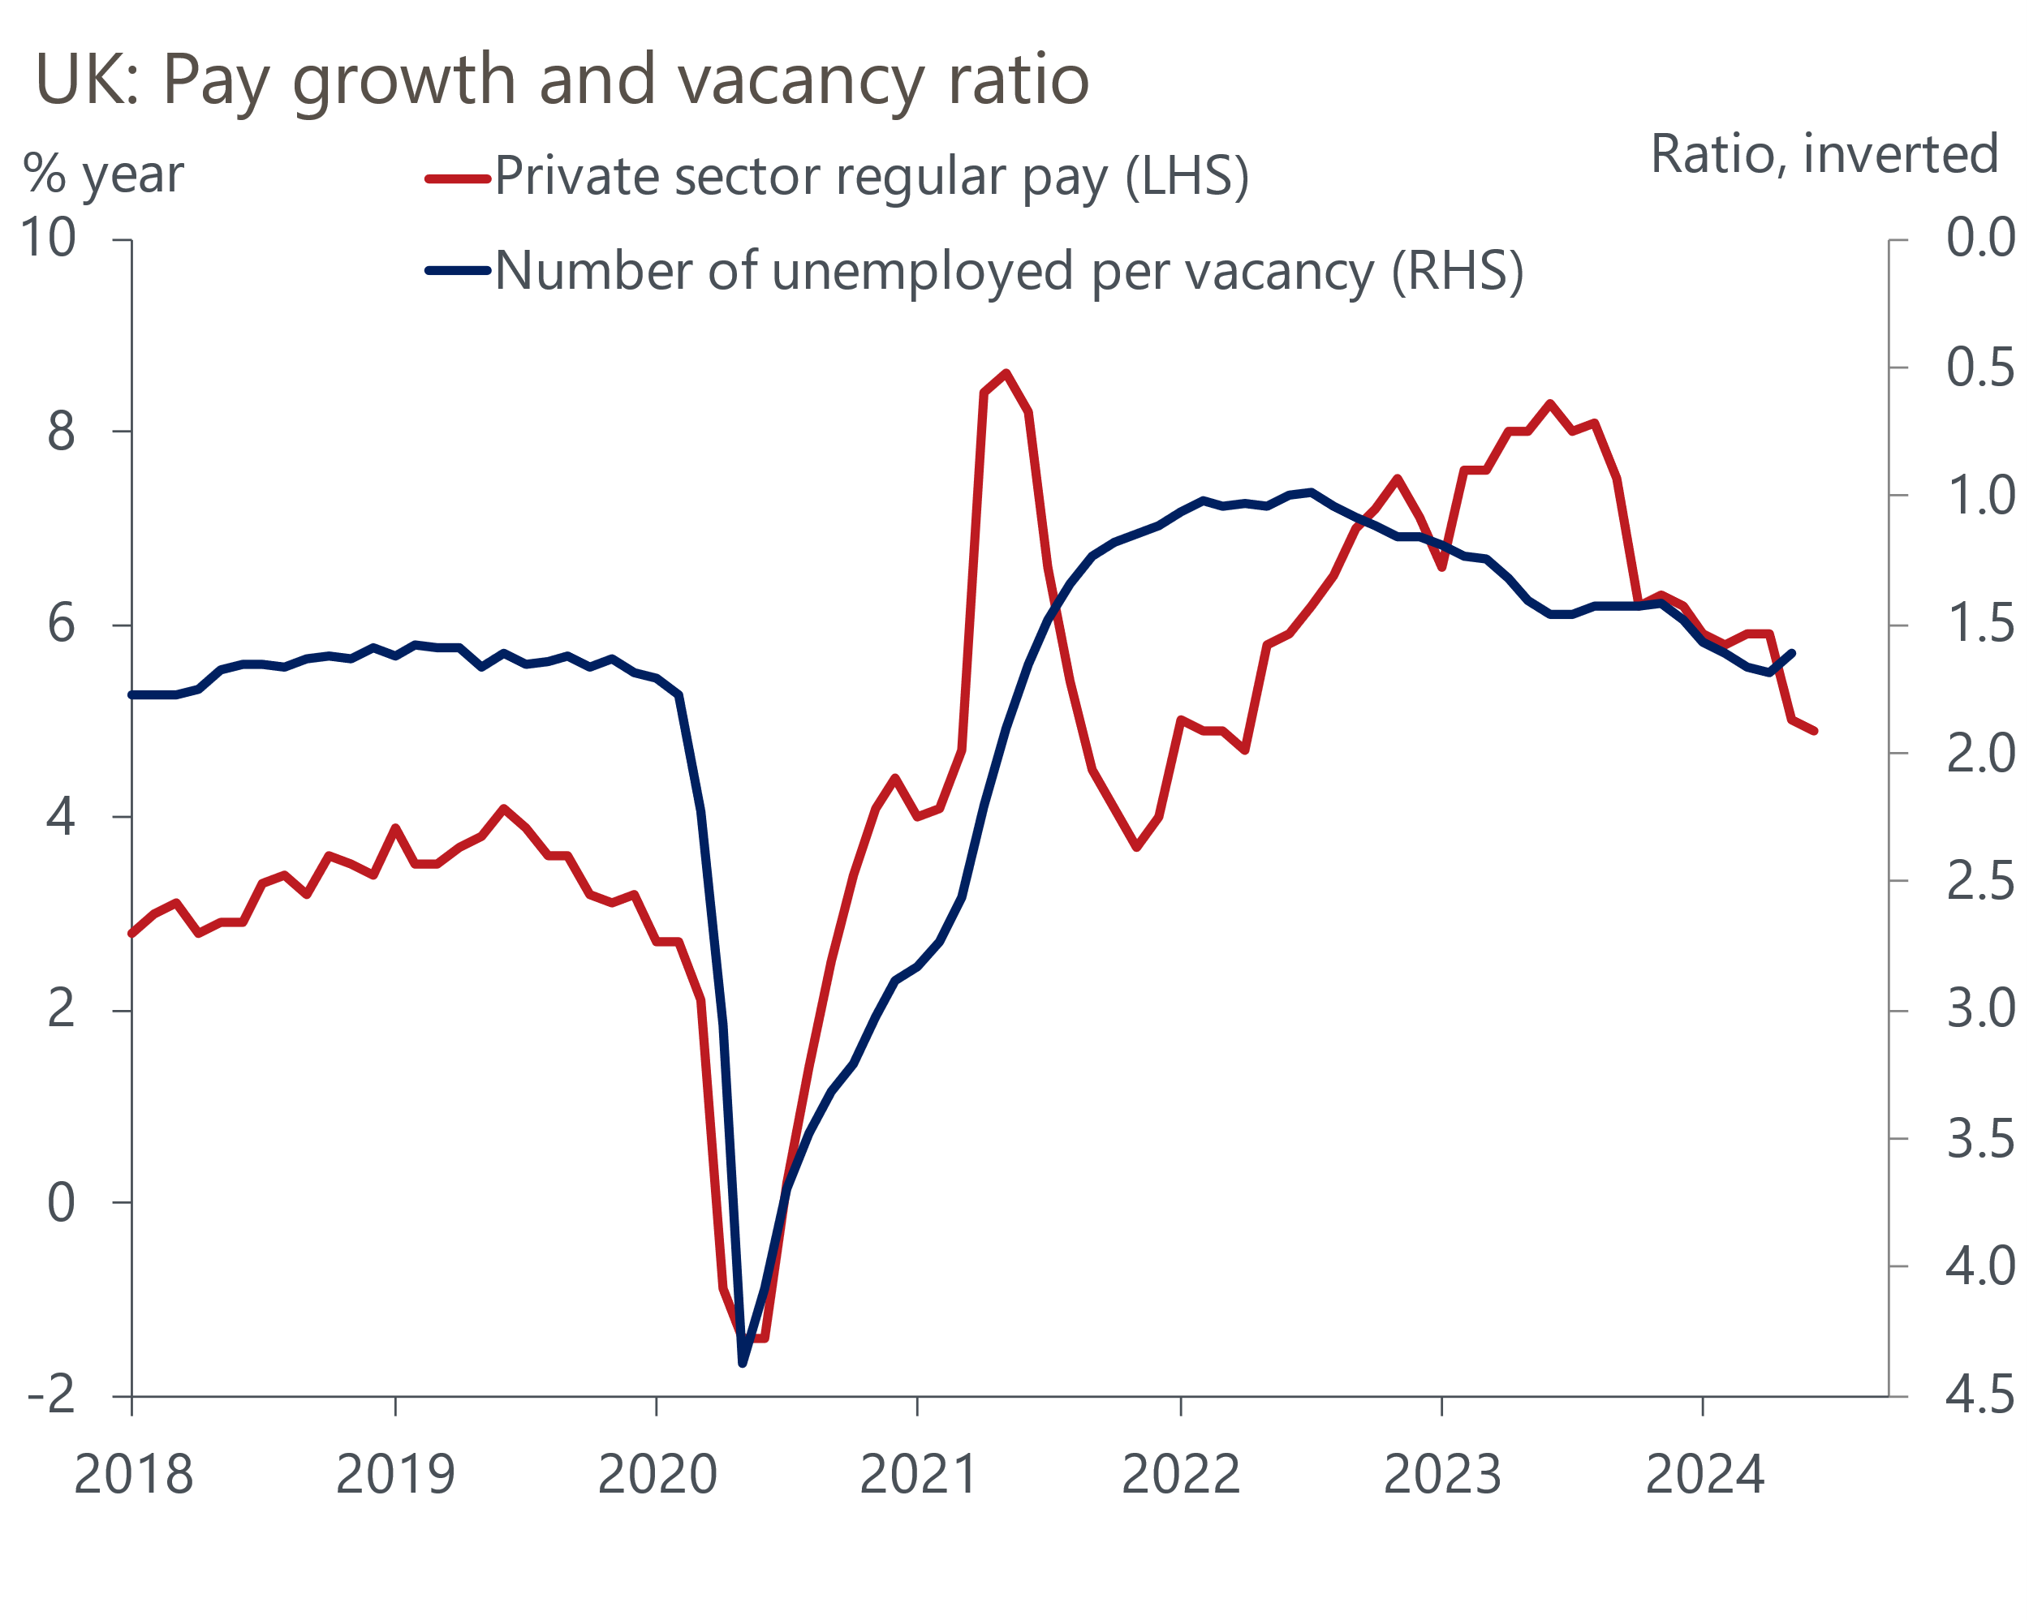
Source: Haver Analytics

The data on labour market quantities wasn't clear-cut. Vacancies continued to edge down, but HMRC's count of payrolled employees rose again. We largely discount the surprise fall in unemployment to 4.2% in Q2 – this was almost entirely due to a very soft single-month reading for June and was emblematic of the volatility caused by the Office for National Statistics' ongoing challenges around low sample sizes. On balance, conditions in the labour market look to have broadly stabilised, after loosening in early-2024.
It was a similar story with Wednesday's inflation release. CPI inflation rose to 2.2% in July from 2% in June, which was mainly due to a smaller drag from the energy category. Though Ofgem's energy price cap was cut by nearly 7% in July, it had fallen by more than twice as much last July. This upward pressure was partly offset by softer services inflation, largely reflecting the unwinding of June's unusual spike in hotel prices.
Though the lower outturn for services inflation undershot the Bank of England's new forecast, we doubt this will have much impact on the MPC's decision-making. The dovish majority have made clear they are placing less weight on backward-looking measures of inflation persistence such as services inflation. Having looked past upside surprises for services inflation in Q2, they are likely to treat undershoots in a similar fashion unless the downside surprises become much more persistent. Meanwhile, the hawks are likely to apply a similar logic to services inflation as pay growth, arguing that while it is slowly moving in the right direction, the latest figures are still too high to think about loosening policy.
Governor Andrew Bailey will offer an update of his views when he speaks at the Jackson Hole symposium on August 23. With little in this week's data to suggest that the picture has changed since August's press conference, we expect him to repeat his message that the MPC "need to be careful not to cut rates too much or too quickly". We continue to expect that the MPC will vote to keep Bank Rate at 5% in September, before delivering another 25bps cut in November.
Elsewhere, GDP was flat in June, having risen by 0.4% m/m in May. June's softer outturn was mostly due to retail sales falling sharply that month and four days of strike action by junior doctors weighing on health output (Chart 2). GDP rose 0.6% q/q in Q2, following growth of 0.7% in Q1, continuing the economy's strong start to 2024. Digging into the details, government consumption was the key pillar of support for growth in Q2. Meanwhile, consumer spending disappointed again, even though real incomes are likely to have risen strongly again in Q2.
Chart 2: Temporary weakness in consumer-facing services weighed on GDP in June
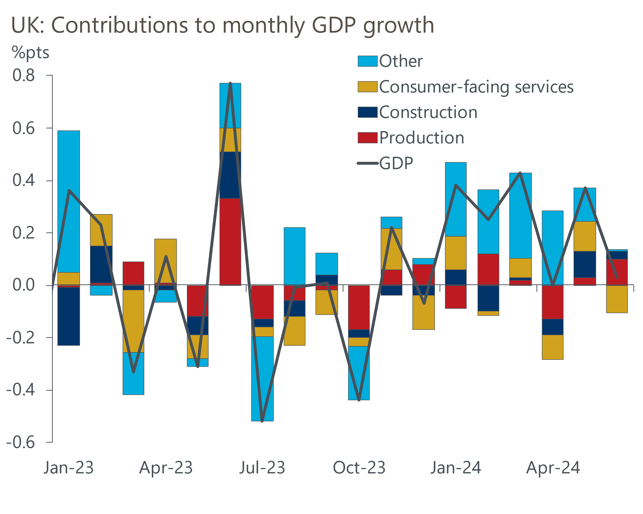
Source: Haver Analytics
July's rebound in retail sales and the end to the junior doctors' strikes means there's a good chance that GDP rose again that month. Further ahead, the outlook for GDP growth looks reasonably positive, with consumers central to prospects. We expect further real wage increases and a less cautious approach towards saving and credit to support stronger consumer spending growth. But with the lagged impact of past interest rate rises continuing to emerge, and fiscal policy tightening, we don't expect the economy to be able to sustain the above-trend pace seen in the past two quarters.

The week ahead
The forward-looking balances in July's S&P Global PMI surveys suggest August's flash survey should report another broad-based pickup in activity. July's manufacturing and services surveys both reported stronger rises in new orders, while hiring also ramped up to cope with the increase in demand. As a result, we expect the manufacturing and services PMIs to edge up to 52.4 and 52.8 respectively. This would leave the composite PMI around 53.1.
Table 1: Week ahead calendar
Date | Events | Period | Measure | Unit | Previous | Forecast
Aug 21 | Public finances | Jul | PSNB ex | £bn | 14.5 | 1.2
Aug 22 | S&P Global manufacturing | Aug | PMI | % bal | 52.1 | 52.4
Aug 22 | S&P Global services | Aug | PMI | % bal | 52.5 | 52.8
Aug 22 | S&P Global composite | Aug | PMI | % bal | 52.8 | 53.1
Source: Oxford Economics

Key forecasts
Table 2: UK forecast overview
(Annual percentage changes unless specified)
 | 2022 | 2023 | 2024 | 2025 | 2026 | 2027
GDP | 4.3 | 0.1 | 1.1 | 1.8 | 1.8 | 1.7
Private consumption | 4.8 | 0.2 | 0.6 | 2.2 | 2.1 | 1.6
Fixed investment | 8.0 | 2.2 | 0.3 | 0.9 | 2.5 | 2.1
Government consumption | 2.3 | 0.5 | 2.7 | 2.8 | 1.6 | 1.5
Exports of goods and services | 9.0 | -0.5 | -0.7 | 2.4 | 2.2 | 1.7
Imports of goods and services | 14.6 | -1.5 | 0.8 | 3.1 | 2.8 | 1.9
Industrial Production | -3.5 | -0.4 | 0.0 | 0.9 | 1.5 | 1.2
Consumer prices | 9.1 | 7.3 | 2.6 | 2.5 | 2.2 | 2.2
Unemployment rate (%) | 3.9 | 4.0 | 4.3 | 4.3 | 4.1 | 3.9
Current a/c balance (% of GDP) | -3.1 | -3.3 | -3.5 | -3.3 | -3.3 | -3.3
Government balance (% of GDP) | 4.4 | 5.0 | 4.1 | 3.2 | 2.5 | 1.7
Cen. bank policy rate (%, EOP) | 3.50 | 5.25 | 4.75 | 3.75 | 2.75 | 2.00
10yr govt. bond yield (%, EOP) | 3.67 | 3.54 | 3.92 | 3.66 | 3.22 | 2.85
Exchange rate (US$ per £, EOP) | 1.20 | 1.27 | 1.28 | 1.28 | 1.30 | 1.32
Exchange rate (euro per £, EOP) | 1.13 | 1.15 | 1.18 | 1.17 | 1.17 | 1.16
Source: Oxford Economics
Table 3: Quarterly forecasts for the UK
 | 2024 |  |  |  | 2025
 | Q1 | Q2 | Q3 | Q4 | Q1 | Q2 | Q3 | Q4
GDP (% year) | 0.3 | 0.9 | 1.3 | 2.0 | 1.8 | 1.7 | 1.9 | 1.9
CPI inflation (% year) | 3.5 | 2.1 | 2.1 | 2.5 | 2.6 | 2.3 | 2.6 | 2.4
Bank Rate (%, EOP) | 5.25 | 5.25 | 5.00 | 4.75 | 4.50 | 4.25 | 4.00 | 3.75
10yr gilt yield (%, EOP) | 3.95 | 4.17 | 3.95 | 3.92 | 3.87 | 3.80 | 3.73 | 3.66
US$ per £ (EOP) | 1.26 | 1.26 | 1.27 | 1.28 | 1.28 | 1.28 | 1.28 | 1.28
Euro per £ (EOP) | 1.17 | 1.18 | 1.18 | 1.18 | 1.18 | 1.18 | 1.17 | 1.17
Source: Oxford Economics

Latest Country Economic Forecast:
July 16, 2024

Recent publications

Data Insights
Noisy retail sales rebounded in July
Flat June completes another strong quarter for GDP
Inflation edged up in July due to energy-related base effects
Pay data offers something for doves and hawks alike
Services activity growth improves, as inflation continues to cool

Research Briefings
Rate-cut cycle kicks off but it’s unlikely to be sequential
Reeves review lays the ground for October tax rises
MPC preview – Markets hold the key to timing of rate cut
Labour's fiscal inheritance and the Reeves Review
MPC prepares the ground for an August rate cut

Contacts

Oxford Economics' UK team
- Andrew Goodwin - Chief UK Economist - agoodwin@oxfordeconomics.com
- Edward Allenby - UK Economist - eallenby@oxfordeconomics.com

